Generating-Unit Outage Screen with Logistic Regression
Short name: Energy_LogReg | L1-logistic (C=0.05, liblinear) on age, ambient C, MW, load factor, days since maint, peak, fuel, region.

Problem Statement
A generating-unit blotter records whether each unit-day had a forced outage or material derate. The task is an interpretable logistic screen from fleet and weather features, an honest imbalance check against the “No event” baseline, and evaluation with a confusion matrix plus ROC. The 12,000-row file is synthetic. Yes includes derates, so the event rate (~26%) is higher than a pure GADS forced-outage rate.

Solution Strategy
- Load energy_units.csv. Count unique unit_id — repeats strain the independence assumption.
- Dummy-encode fuel and region (drop_first; coal and ERCOT are the references); y = 1 if Yes.
- Fit 80/20 seed=1, LogisticRegression(C=0.05, penalty='l1', solver='liblinear').
- Read signs against ops knowledge: age and peak should raise log-odds; hydro/nuclear/solar should sit below coal.
- Alternates: scaled pipeline, L2, age-only card, maint_overdue + operator, class_weight, threshold as reserve %.

Solution
Metric | Value | Metric | Value
n / event rate | 12,000 / 25.9% | Test accuracy | 0.779
Confusion (t=0.5) | 1739 64 / 467 130 | Event prec / recall | 0.67 / 0.22
ROC AUC | 0.757 | L1 zeros / intercept | 4 of 16 / −2.08
Lift over the test No-baseline (~0.75) is about 3 accuracy points. Peak hour (+0.38) and age (+0.045/year) lead the risk side; hydro/solar/nuclear sit well below coal. Adding maint_overdue (β ≈ +0.78) edges AUC to ~0.76.
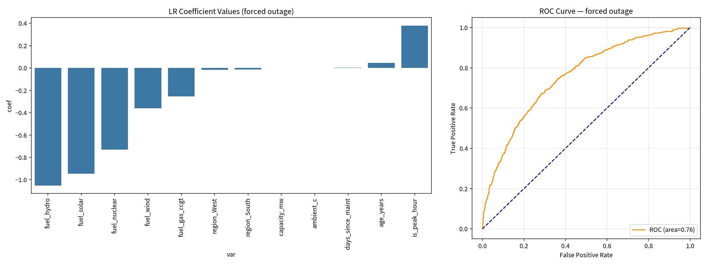
Left: L1 coefficients (zeros dropped). Right: hold-out ROC. t=0.20 raises event-recall to 0.85 and floods false alarms — a fat reserve stack.

Key Takeaways
- Accuracy 78% next to a 74% No baseline is not a reliability program. Lead with AUC and event-recall.
- Threshold is a reserve policy: low t holds more MW of caution; high t misses most derates.
- Repeated unit_id means ordinary logistic SEs are too small. Cluster or use a mixed model before publication.
- Good fit: fleet screens, GADS teaching, threshold workshops. Not a fit: live dispatch, fuel-bashing headlines, billing.
- Synthetic blotter. Not an operating tool.

